

**American International University- Bangladesh**

**CSC 3222: Web Technologies**

**CO1 and CO3 Evaluation**

**Project Report**

**Fall 2019-2020**

**Project Title: Tour Management System**

**Section: F**

|  |  |
| --- | --- |
| Student Name | Student Id |
| Hasan, Shazid | **16-31253-1** |
| Eila, Farzana Akter | **16-32104-2** |
| Islam, Sumaiya | **16-32194-2** |
| Samin, MD Towhidur | **17-34181-1** |

**Introduction:**

To be a skilled web developer as well as designer and also to learn about business policy or to know how to make easier for customer to purchase and deliver best products, we are doing this project.

**Background Study**

We have used W3 school and also YouTube to get some extra ideas. As usual most of the term we have learnt so far from our honourable faculty.

**Requirement Analysis:**

1. **User Category:**

There are 3 types of Users here. They are:

* Host
* Traveler
* Admin

1. **Feature List:**

In this project the Host has the following features:

* Find place to visit
* Registration
* Invite
* contact

In this project the Traveler has the following features:

* Finding
* Find by category, place and price
* Log in
* Selecting package
* Payment

In this project the Admin has the following features:

* Approve registration
* Adding tour plan
* Cancelation of booking
* Delete registered user
* Cancel tour plan
* Updating date and time

**Design:**

Draw an entity diagram of your project here.

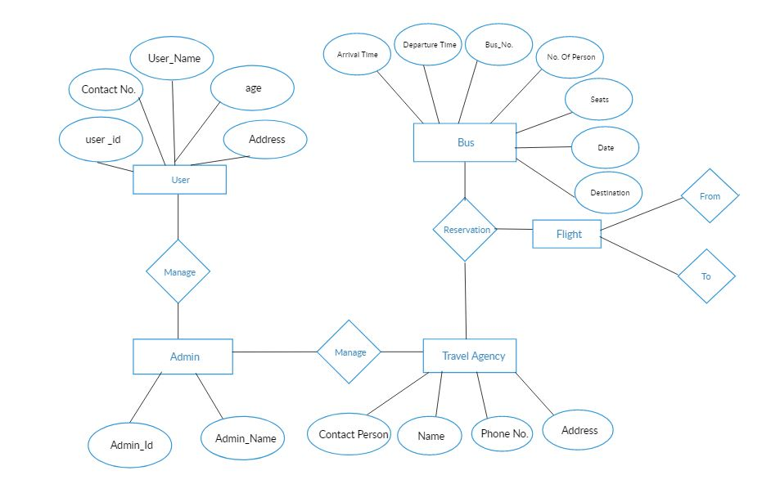

**Tools Used:**

To develop this project, we have used the following:

• php

• Bootstrap

• html

• css

• xamp

**System Images against the Specification:**

Travelers need to register first with all of the information. After that they will be able to log in to websites. The hosts or other users also can visit the web sites to know details about Tour. User can find tour plan with categories. The higher the category the greater the price policy is applicable with reasonable facilities. They can find their destination by searching too.

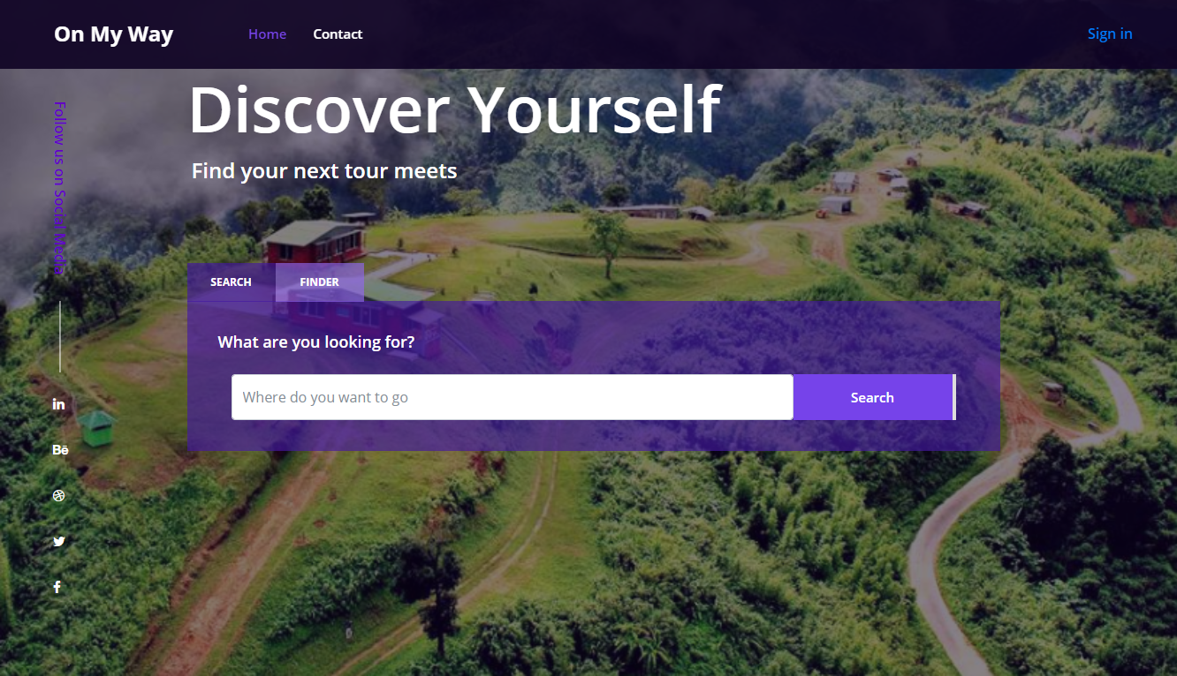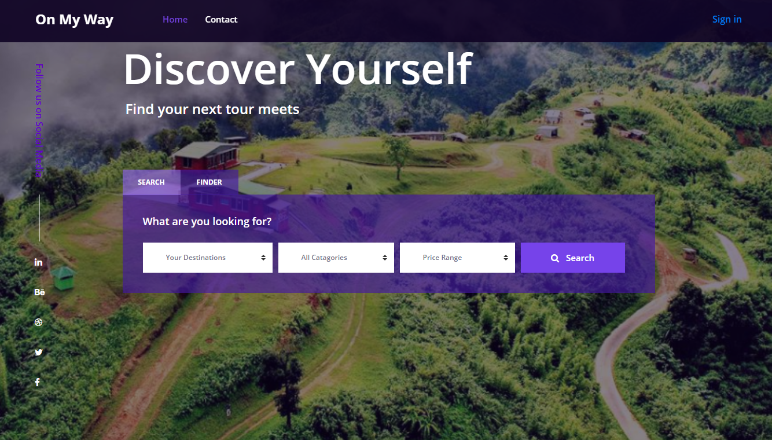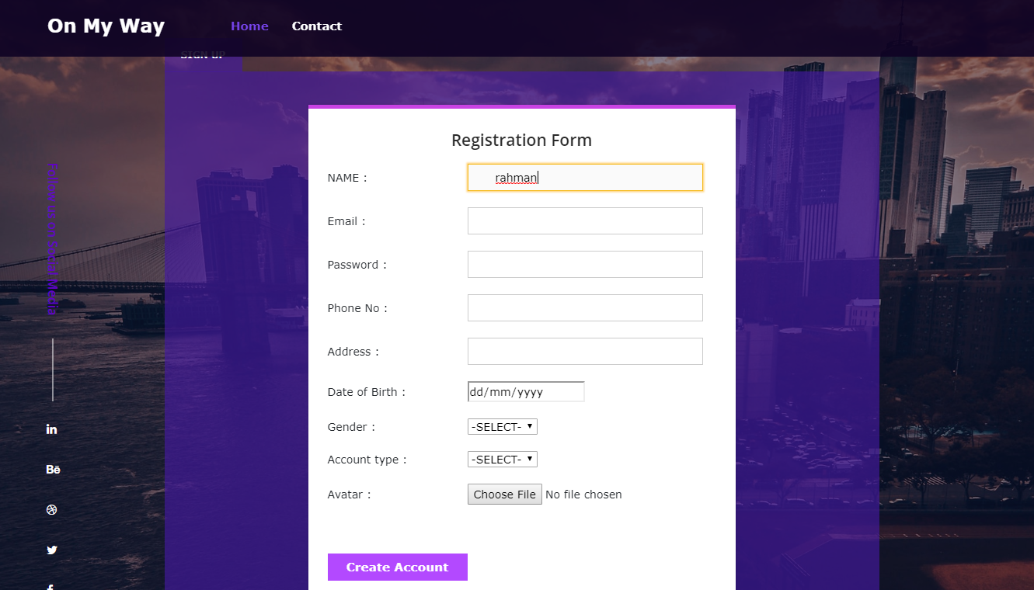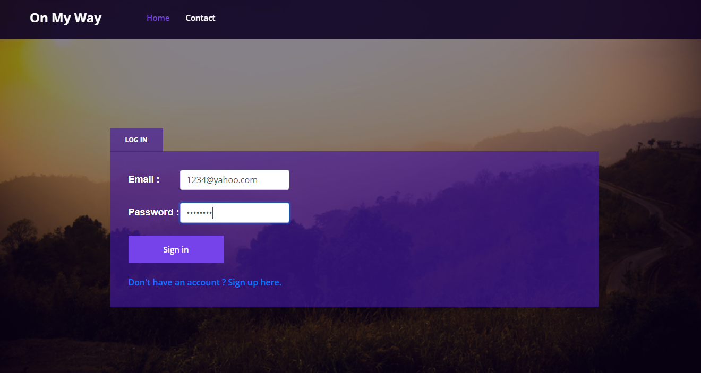

**Impact of this Project:**

Now-a-days people tend to visit or give tour somewhere with their family and friends and most of the time they come up with a plan to go somewhere and the last moment all the plan get cancelled. Most of the time it happens because of unpredictable budgets, availability of transport systems, security, availability of rooms or residence etc. Also, they face problems for advance booking of tickets for transports, residence, visit etc. We are providing most of these facilities through our website so that one can easily choose a place to travel and within their budget they can complete the selected places within right time.

**Limitations and Possible Future Improvements:**

Since we are not familiar with most of the features of web technology, we have just implemented a very basic of our project. Some of the features or buttons may not work. We have not connected database yet.

We wish to add more features and referenced web sites or links so that we can access data from those and able to use those in our project. We are going to add some of the effective payment options soon.

**Thank You**